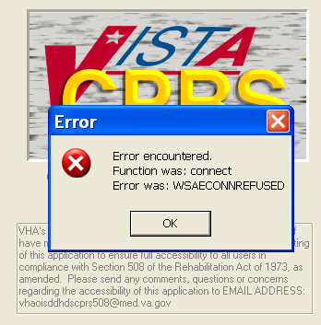

This error means the “Listener” is down. Contact IT to start Listener

IT Staff: D STRT^XWBTCP() will start the listener

