HOW TO DELETE ENCOUNTER INFO ENTERED IN ERROR

- HIGHLIGHT THE PROCEDURE OR DIAGNOSIS YOU WANT TO REMOVE
- SELECT REMOVE AT THE BOTOM

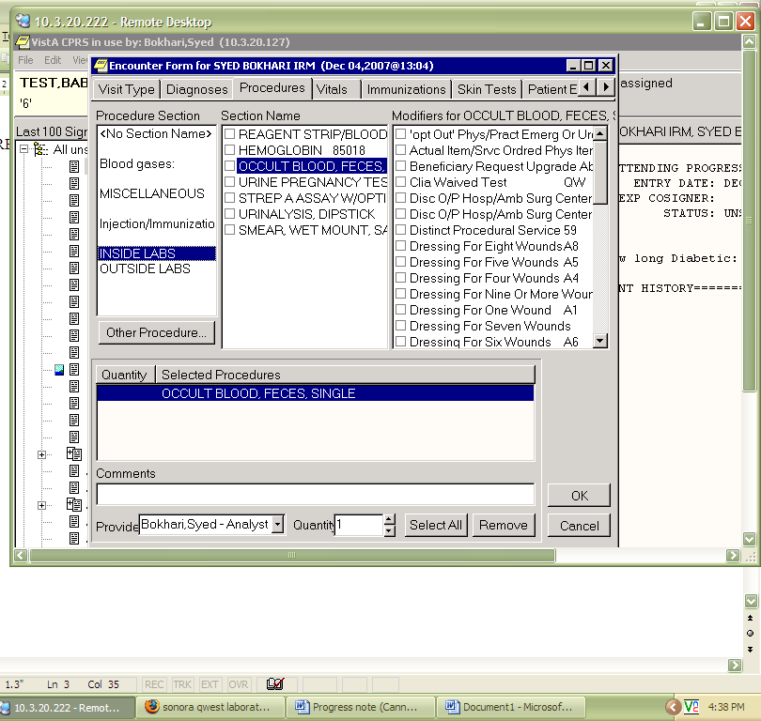

URINE CULTURE/COLONY COUNTLTURE/COLONY COUNT

