CONNECTION LOST ERROR:

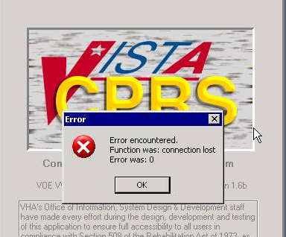

There are two things you can do to resolve it:
- Window Level
- Run
- CMD
- Telnet 10.3.20.xxx 9250

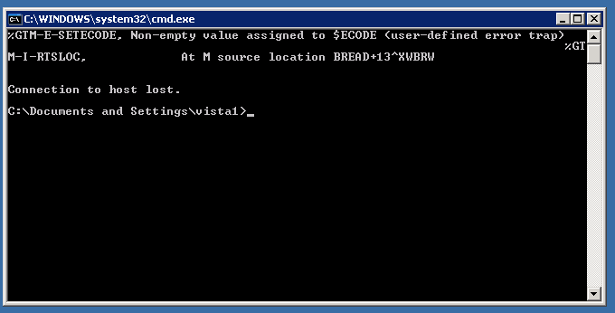

- Linux Level

login as: CCCC
Using keyboard-interactive authentication.
Password:
Last login: Tue Jan 29 12:06:20 2008 from 10.3.20.xxx
Have a lot of fun...
syed@vistaweb:~> su
Password:
vistaweb:/home/syed # /etc/init.d/xinetd restart
Shutting down xinetd: done
Starting INET services. (xinetd) done
vistaweb:/home/syed #

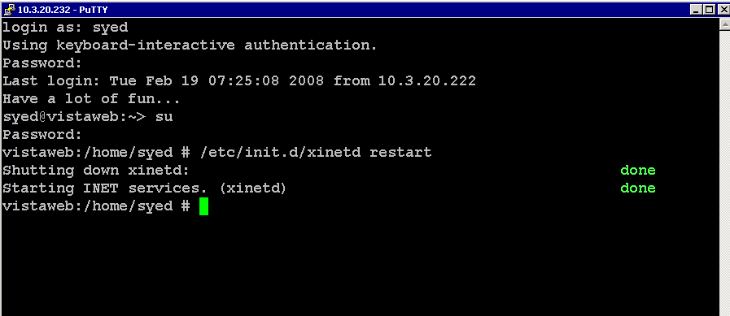

login as: voep
Using keyboard-interactive authentication.
Password:
Last login: Mon Jan 28 12:37:44 2008 from xxxxx
Have a lot of fun...
@vistaweb:~> su
Password:

voet@vistaweb:~> su
Password:
vistaweb:/home/voet # /etc/init.d/xinetd restart
Shutting down xinetd: done
Starting INET services. (xinetd) done

FROM CAMERON:

Here's the code in XWBRW

F D Q:DONE
. S S=L-$L(R),R=R_$E(XWBRBUF,1,S),XWBRBUF=$E(XWBRBUF,S+1,999999)
. I ($L(R)=L)!(R[$C(4))!(C>TO) S DONE=1 Q
. R XWBRBUF#S:2 S:'$T C=C+1 S:$L(XWBRBUF) C=0 I +$DEVICE S DONE=1
. I $G(XWBDEBUG)>2,$L(XWBRBUF) D LOG^XWBDLOG("rd: "_$E(XWBRBUF,1,252))
. Q
I $L(R)<L,'$G(SE) S $ECODE=",U411," ;Throw Error, Did not read full length
Q R

