INSTRUCTIONS TO FIND UNSIGNED/UNCOSIGNED DOCUMENTS

To find unsigned/uncosigned documents run the menu option Search for Selected Documents sorting by status of unsigned and uncosigned documents and search category of Service.

Select menu option: Text Integration Utilities (MIS Manager)
Search for Selected Documents [TIU SEARCH LIST MGR]

Select Status: UNVERIFIED// ?

1 undictated 5 unsigned 9 purged
2 untranscribed 6 uncosigned 10 deleted
3 unreleased 7 completed 11 retracted
4 unverified 8 amended

Enter selection(s) by typing the name(s), number(s), or abbreviation(s).

Select Status: UNVERIFIED// 5-6 unsigned uncosigned

Select CLINICAL DOCUMENTS Type(s): Progress Notes// Progress Notes

Select SEARCH CATEGORIES: AUTHOR// ?

1 All Categories 6 Patient 11 Transcriptionist
2 Author 7 Problem 12 Treating Specialty
3 Division 8 Service 13 Visit
4 Expected Cosigner 9 Subject
5 Hospital Location 10 Title

Enter selection(s) by typing the name(s), number(s), or abbreviation(s).

Select SEARCH CATEGORIES: AUTHOR// SE Service
Select SERVICE: MEDICINE
Start Reference Date [Time]: T-7//
Ending Reference Date [Time]: NOW//
Searching for the documents.........................................

The patient list will appear here, then you have several menu option choices (ie print)
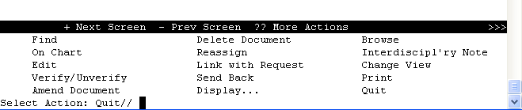

Unsigned documents appear as an alert in CPRS GUI. Remember that CPRS GUI is patient specific. When in the notes tab of the patient record when you click on unsigned or uncosigned notes it is for that specific patient only. It will not bring up all unsigned/uncosigned patient notes for the clinician to sign. This must be done through VistA.

The easiest way for a clinician to find their unsigned/uncosigned documents is in Vista, select the TIU menu from their practitioner menu as below:

Select Practitioner Menu Option: TIU Progress Notes/Discharge Summary [TIU]

--- Clinician's Menu ---

Select Progress Notes/Discharge Summary [TIU] Option: ?

1 Progress Notes User Menu ...
2 Discharge Summary User Menu ...
3 Integrated Document Management ...
4 Personal Preferences ...

Select Progress Notes/Discharge Summary [TIU] Option: 3 Integrated Document Management

Select Integrated Document Management Option: ?

1 Individual Patient Document
2 All MY UNSIGNED Documents
3 Multiple Patient Documents
4 Enter/edit Document

Select Integrated Document Management Option: 2 All MY UNSIGNED Documents

A list of unsigned/uncosigned documents appear and they may all be selected and added to signature list with prompting at the end to enter electronic signature code.

