Provider is unable to sign note

1. Check the TIU USER CLASS
2. Ensure that the Effective Date is prior to any CREATED notes.

To do: use menu option
TIU Maintenance Menu
User Class Management
List Membership by User

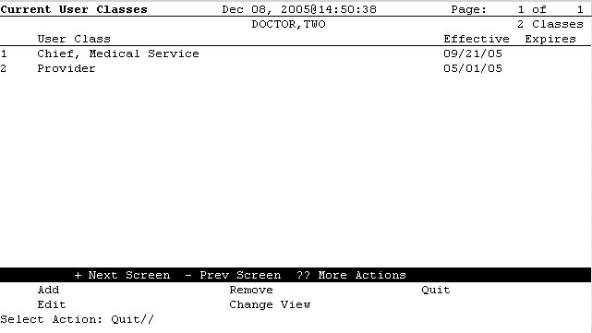
If the user class is not correct you may use Add – to add a new one, or edit to edit the existing one. You should never remove a tiu class, instead use edit to enter an expiration date.

