Application Context Error

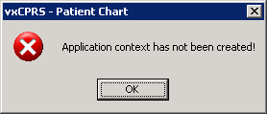

This error is displayed when the user tries to enter CPRS GUI and does not have the secondary menu option OR CPRS GUI CHART

GIVE USE THE OR CPRS GUI CHART MENU OPTION.

