Steps:

- Add Verified Duplicate Pair using XDRU Utilities
- Change “Merging Status” from Not Ready to Ready In “Duplicate Record” File using FILEMAN
- Approve verified duplicate for merging using XDRO Operations
- Schedule Process to Merge Verified Duplicates using XDRM Manager Utilities

Details:
::::::::::::::::::::::::::::::::::::::::::::::::::: Step 1 ::::::::::::::::::::::::::::::::::::::::::::::::::::::
Add Verified Duplicate Pair using XDRU Utilities
::::::::::::::::::::::::::::::::::::::::::::::::::::::::::::::::::::::::::::::::::::::::::::::::::::::::::::::::::

XDR MAIN MENU Duplicate Resolution System
Duplicate Resolution System Menu

XDRO Operations ...
XDRU Utilities ...
XDRM Manager Utilities ...

Select Duplicate Resolution System Option: UT Utilities
Duplicate Resolution Utilities Menu

ADD Add Verified Duplicate Pair
CMP Check Merge Process Status (reverse order)
CHCK Check Pair of Records to see if Duplicates
DSS Display Search Status
EDIT Edit the Status Field of a Duplicate Record
FIND Find Potential Duplicates for an Entry in a File
VAL Identify Potential Merge Problems
PRNT Print List of File Duplicates
SCAN Scan Possible Duplicates
TSF Tally STATUS and MERGE STATUS Fields
VIEW View Duplicate Record Entries

Select Utilities Option: AD Add Verified Duplicate Pair
Add entries from which File: PATIENT

Do you want to bypass the potential duplicate threshold % check (Y/N)? NO

Potential duplicate threshold % will NOT be bypassed!

Select PATIENT: < Deleted DOB> Enter here DOB of the Duplicate pt.
1 < Deleted for HIPPA >
2 < DOB > < Pt namedeleted > <W> F < DOB > 119716
3 < Deleted for HIPPA >
4 < Deleted for HIPPA >
5 < Deleted for HIPPA >
ENTER '^' TO STOP, OR
CHOOSE 1-5:
6 < Deleted for HIPPA >
7 < DOB > < Pt name deleted > <W> F < DOB > 135593
< Deleted for HIPPA >

CHOOSE 1-9: 2 Select 1st Duplicate pt (see above: Pt #2 is our 1st duplicate pt)

< Patient name deleted > <W> F <DOB> 119716
Another PATIENT: <DOB> Here enter DOB again to select 2nd Duplicate pt ( See above : Pt # 7 is our 2nd duplicate pt)

CHOOSE 1-9: 7
< Patinet name deleted> <W> F <DOB> 135593

You will be adding the following pair of records to the duplicate record file:

RECORD1: < Patient name >
RECORD2: < Patient name >


Enter RETURN to continue or '^' to exit: Ok, continuing, hold on ...

RECORD1 contains fewer data elements, usually this would indicate
that this record would be merged INTO the other.
Start of Patient Verification process. Use Return (Enter) key to move through the pt verification process
Determine if these entries ARE or ARE NOT duplicates.

RECORD1 [#30414] RECORD2 [#101925]
< Patent name Deleted> < Patient name Deleted>
CMOR SCORE = 30 CMOR SCORE = 350
----------------------------------------------------------------------------

**** NAME "< Patient name >" "< Patient name >"

SEX FEMALE FEMALE

DATE OF BIRTH <DOB> <DOB>

MARITAL STATUS MARRIED

Enter RETURN to continue or '^' to exit:
RECORD1 [#30414] RECORD2 [#101925]
< Patent name Deleted> < Patient name Deleted>
CMOR SCORE = 30 CMOR SCORE = 350
----------------------------------------------------------------------------

CHECK FOR DUPLICATE YES YES

**** STREET ADDRESS [LINE "<Address>" "<Address>"
1]

ZIP+4 85301 85301

Enter RETURN to continue or '^' to exit:
RECORD1 [#30414] RECORD2 [#101925]
< Patent name Deleted> < Patient name Deleted>
CMOR SCORE = 30 CMOR SCORE = 350
----------------------------------------------------------------------------

CITY "<Deleted>" "<Deleted>"

STATE ARIZONA ARIZONA

ZIP CODE "85301" "85301"

**** ADDRESS CHANGE DT/TM 2/4/09 08:59:33 10/28/08 08:20:43

Enter RETURN to continue or '^' to exit:
RECORD1 [#30414] RECORD2 [#101925]
< Patent name Deleted> < Patient name Deleted>
CMOR SCORE = 30 CMOR SCORE = 350
----------------------------------------------------------------------------

ADDRESS CHANGE SOURC VAMC VAMCE

ADDRESS CHANGE SITE CLINICA ADELANTE, IN CLINICA ADELANTE, INC

ADDRESS CHANGE USER HL,ADT HL,ADT

Enter RETURN to continue or '^' to exit:
RECORD1 [#30414] RECORD2 [#101925]
< Patent name Deleted> < Patient name Deleted>

CMOR SCORE = 30 CMOR SCORE = 350
----------------------------------------------------------------------------

PHONE NUMBER [RESIDE "<Deleted>" "<Deleted>"
NCE]

SERVICE CONNECTED? NO NO

COVERED BY HEALTH IN YES YES
SURANCE?

Enter RETURN to continue or '^' to exit:
RECORD1 [#30414] RECORD2 [#101925]
< Patent name Deleted> < Patient name Deleted>
CMOR SCORE = 30 CMOR SCORE = 350
----------------------------------------------------------------------------

PRIMARY ELIGIBILITY EHR PATIENT EHR PATIENT
CODE

**** PRIMARY LONG ID "119716" "135593"

**** PRIMARY SHORT ID "9716" "5593"

Enter RETURN to continue or '^' to exit:
RECORD1 [#30414] RECORD2 [#101925]
< Patent name Deleted> < Patient name Deleted>

CMOR SCORE = 30 CMOR SCORE = 350
----------------------------------------------------------------------------

NAME COMPONENTS 2 2

LABORATORY REFERENCE 2914

**** INTEGRATION CONTROL 500029564 500096628
NUMBER

Enter RETURN to continue or '^' to exit:
RECORD1 [#30414] RECORD2 [#101925]
< Patent name Deleted> < Patient name Deleted>
CMOR SCORE = 30 CMOR SCORE = 350
----------------------------------------------------------------------------

**** ICN CHECKSUM "796961" "966179"

COORDINATING MASTER CLINICA ADELANTE, INC

CLINICA ADELANTE, INC OF RECORD

LOCALLY ASSIGNED ICN YES YES

Enter RETURN to continue or '^' to exit:
RECORD1 [#30414] RECORD2 [#101925]
< Patent name Deleted> < Patient name Deleted>
CMOR SCORE = 30 CMOR SCORE = 350
----------------------------------------------------------------------------

**** CMOR ACTIVITY SCORE 30 350

SCORE CALCULATION DA 2/10/09 2/10/09
TE

VETERAN (Y/N)? NO NO

Enter RETURN to continue or '^' to exit:
RECORD1 [#30414] RECORD2 [#101925]
< Patent name Deleted> < Patient name Deleted>
CMOR SCORE = 30 CMOR SCORE = 350
----------------------------------------------------------------------------

INSURANCE TYPE 2 entries 4 entries

RACE INFORMATION 1 entry 1 entry

PATIENT ELIGIBILITIES 1 entry 1 entry

CMOR HISTORY 1 entry ---

Enter RETURN to continue or '^' to exit:
RECORD1 [#30414] RECORD2 [#101925]
< Patent name Deleted> < Patient name Deleted>
CMOR SCORE = 30 CMOR SCORE = 350
----------------------------------------------------------------------------

APPOINTMENT 2 entries 2 entries

Select one of the following:

V VERIFIED DUPLICATE
N VERIFIED, NOT A DUPLICATE
U UNABLE TO DETERMINE
H HEALTH SUMMARY
R REVIEW DATA AGAIN
S SELECT/REVIEW OVERWRITES

Select Action: HEALTH SUMMARY// VERIFIED DUPLICATE

RECORD1 [#30414] RECORD2 [#101925]
< Patient name deleted> < Patient name deleted>
Completion of Patient Verification process.

Select one of the following:

1 RECORD1 INTO RECORD2
2 RECORD2 INTO RECORD1

Which record (1 or 2) should be MERGED INTO the other record: RECORD1 INTO RECOR
D2// 1 RECORD1 INTO RECORD2 ( See warning on page 2 …. For this pt record 1 should be merged to Record 2)

Do you want to ADD another pair (Y/N)? NO

:::::::::::::::::::::::::::::::::::::::::::::::::::::: Step 2 :::::::::::::::::::::::::::::::::::::::::::::::::::::::::::::
Change “Merging Status” from Not Ready to Ready In “Duplicate Record” File using FILEMAN
:::::::::::::::::::::::::::::::::::::::::::::::::::::::::::::::::::::::::::::::::::::::::::::::::::::::::::::::::::::::::::::

Select Systems Manager Menu Option: FM VA FileMan

VA FileMan Version 22.0

Enter or Edit File Entries
Print File Entries
Search File Entries
Modify File Attributes
Inquire to File Entries
Utility Functions ...
Data Dictionary Utilities ...
Transfer Entries
Other Options ...

Select VA FileMan Option: ENter or Edit File Entries

INPUT TO WHAT FILE: DUPLICATE RECORD//
EDIT WHICH FIELD: ALL// MERGE STATUS
THEN EDIT FIELD:

Select DUPLICATE RECORD RECORD1: < DOB Deleted> This is DOB of the duplicate patient

Searching for a PATIENT, (pointed-to by RECORD1)

1 <DOB deleted> MERGING INTO `101925 USE THAT ENTRY <Patient name> <DOB> < NO
<Unresolved potential duplicate>
2 <Patient name> <DOB> NO

CHOOSE 1-2: 1
MERGING INTO `101925 USE THAT ENTRY <Patient name> <DOB> NO
<Unresolved potential duplicate>
The patient you have selected is a 'verified duplicate' of
<Patient name> <DOB>
If you are adding data for this patient please reselect!
...OK? Yes// (Yes) < Pt name deleted> VERIFIED DUPLICATE
MERGE STATUS: NOT READY// RE READY

Exit file man and go back to XDR MAIN MENU Duplicate Resolution System

:::::::::::::::::::::::::::::::::::::::::::::::::::::: Step 3:::::::::::::::::::::::::::::::::::::::::::::::::::::::::::::
Approve verified duplicate for merging using XDRO Operations
:::::::::::::::::::::::::::::::::::::::::::::::::::::::::::::::::::::::::::::::::::::::::::::::::::::::::::::::::::::::::::::

XDRO Operations ...
XDRU Utilities ...
XDRM Manager Utilities ...

Select Duplicate Resolution System Option: Operations
Duplicate Resolution Operations Menu

APP Approve verified duplicates for merging
VPD Verify Potential Duplicates
ADR Ancillary Data Review

Select Operations Option: APP Approve verified duplicates for merging

1 Entries are awaiting approval for merging Return to continue...

1 < Patient name deleted> -- [30414]
< patient name deleted> -- [101925]

Select entries to approve them for merging: (1-1): 1

:::::::::::::::::::::::::::::::::::::::::::::::::::::: Step 4:::::::::::::::::::::::::::::::::::::::::::::::::::::::::::::
Schedule Process to Merge Verified Duplicates using XDRM Manager Utilities
:::::::::::::::::::::::::::::::::::::::::::::::::::::::::::::::::::::::::::::::::::::::::::::::::::::::::::::::::::::::::::::
XDRO Operations ...
XDRU Utilities ...
XDRM Manager Utilities ...

Select Duplicate Resolution System Option: MANAGer Utilities
Duplicate Manager Utilities Menu

EDT Edit Site Parameters
LIST List File Entries Identified in Preliminary Scan
SCN Preliminary Scan of File for Errors
PRGE Purge Duplicate Record File
PRGM Purge Merge Process File
RES Restart a Merge Process
SCH Schedule Process to Merge Verified Duplicates
SRCH Start/Halt Duplicate Search
STOP STOP an Active Merge Process

Select Manager Utilities Option: SCH Schedule Process to Merge Verified Duplicates

1 Entries Ready to be included in merge
XDRX(30414,101925)=128

This process will take a **LONG** time (usually over 15 hours, and sometimes
considerably longer), but you CAN stop and restart the process when you
want using the options. OK? YES

Name for Merge Process: DUP PT FEB 10, 09 @ 220PM : 20pm PM
XDRX(30414,101925)=128

START DATE/TIME: N (FEB 10, 2009@14:20:12)

Merge process 'DUP PT FEB 10,09 @ 2:20 PM' for Verified Duplicates in File 2 scheduled
as task 7078354.

================================ END =======================================

SUMMARY:

- XDR MAIN MENU Duplicate Resolution System
- Select XDRU Utilities
- Select “Add Verified Duplicate Pair”
  - Use patient’s DOB to pull up duplicate pt
  - Select both duplicate pt one by one
  - Go through verification process
  - Merge Record 1 into 2 or Record 2 into 1. This should be based on
    - Experience
    - Prompt ( e.g. page 2 “RECORD1 contains fewer data elements, usually this would indicate that this record would be merged INTO the other”

- Go to “Duplicate Record” File using file man
- Change “Merging Status” from Not Ready to Ready for the duplicate patient(s) added in “Add Verified Duplicate Pair” see # 3 above.
- Select XDRO Operations
- Select “Approve verified duplicate” for merging
- Select XDRM Manager Utilities
- Select “Schedule Process to Merge Verified Duplicates”

Note: Before running a duplicate process make sure the patients are genuinely duplicate patients. Duplicate confirmation can be done by
- *Potential duplicate threshold %:
- Provider : They can also confirm the pts in EMR are duplicate
- Through file man

* Potential duplicate threshold %: This filed contains a computed percentage based on the values defined in the duplicate tests. When record pair scores evaluate equal to or above this percentage they are considered to be potential duplicates. Record pairs may differ on the maximum score to which the percentage threshold is applied.

Appendix I
Duplicate patient # 1 : ID 119716 Duplicate patient # 2 : ID 135593

Duplicate patient # 1 Cover sheet:
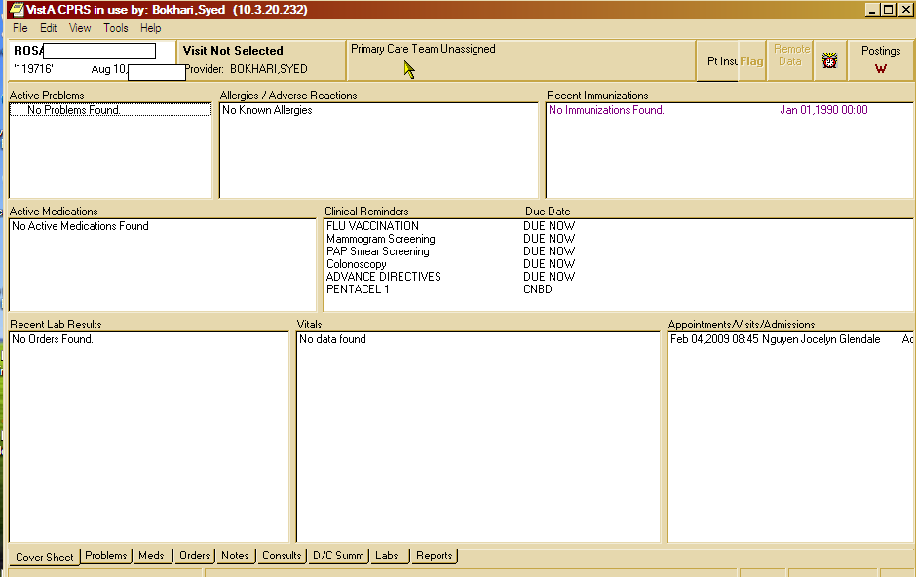

Duplicate patient # 2 Cover sheet:
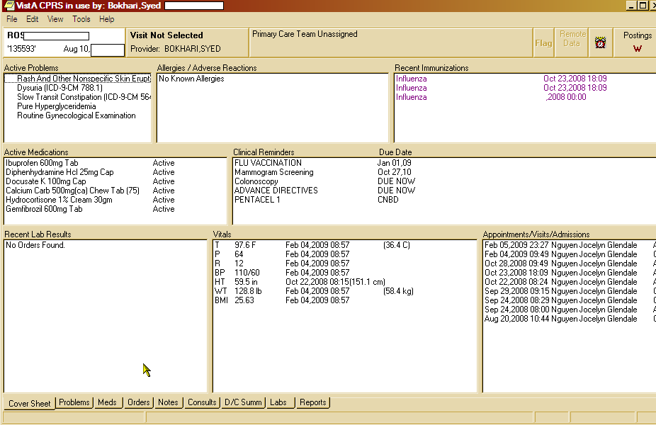

Appendix I continue:

Duplicate patient # 1 Progress notes:

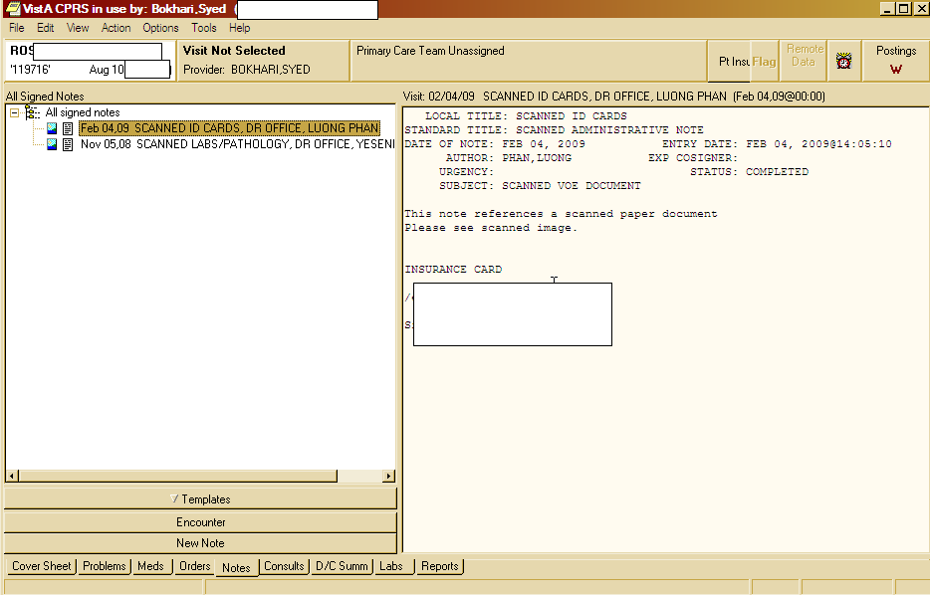

Duplicate patient # 2 progress notes:
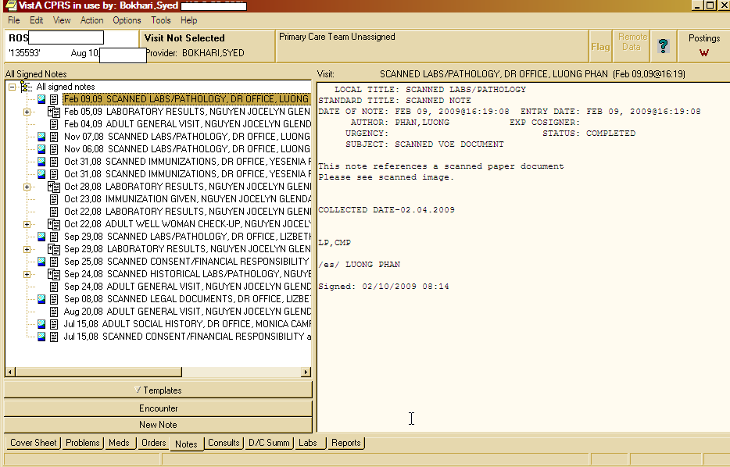

Appendix II

Duplicate pt after Step 1 (verification of duplicate patient)
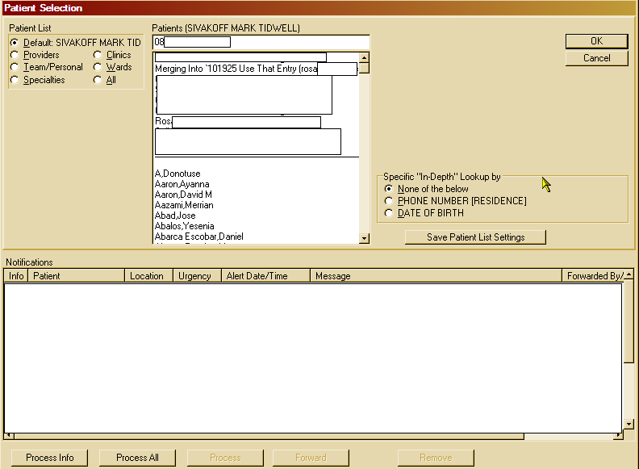

Appendix III
After Step 2 through 4:
After merging process has finished. You can see Feb 4 and November 5 scanned doc of patient # 1 (ID 119716) are there with other documents of patient # 2 (ID 135593). This is a successful merge.

