Patient Record Flags (PRF)

Patient record flags are separated into 2 categories: Category I National and Category II local. A single Category I flag named “Behavioral” is included in the software. The purpose of this PRF is to alert medical staff and employees of patients whose behavior or characteristics may pose a threat either to their safety, the safety of other patients, or compromise the delivery of their medical care. Category II PRFs are locally established by individual sites.

Mail group

Mail group: DGPF BEHAVIORAL FLAG REVIEW is the default mail group for receiving Patient Record Flag Assignment Review notifications.

To assign a patient record flag

In Vista you will need menu option: Patient Record Flags Main Menu ... [DGPF RECORD FLAGS MAIN MENU]
And the following keys:
1. DGPF LOCAL FLAG EDIT: This security key will be used to control user access to the Record Flag Management [DGPF RECORD FLAG MANAGEMENT] option action items, AF (Add New Flag) and EF (Edit Flag).
2. DGPF PRF ACCESS: This security key is used to control access to the Patient Record Flags module of the Registration package. Holders of this key will be able to display record flag detail, patient assignment detail and generate reports.
3. DGPF PRF CONFIG: This security key controls access to the PRF System
Configuration [DGPF PRF SYSTEM CONFIGURATION] option.
4. DGPF RECORD FLAG ASSIGNMENT: This security key will be used to control user access to the following protocol actions within the List Manager, Record Flag Assignment [DGPF RECORD FLAG ASSIGNMENT] option: AF (Assign Flag) [DGPF ASSIGN FLAG]; EF (Edit Flag Assignment) [DGPF EDIT ASSIGNMENT]; CO Change Assignment Ownership [DGPF CHANGE ASSIGNMENT OWNERSHIP]

Step 1: Assign the flag
Type Test then type Patient Record Flags
Patient Record Flags Main Menu (select the option on BOLD)
RM Record Flag Reports Menu ...
FA Record Flag Assignment
FM Record Flag Management
IRM PRF System Configuration

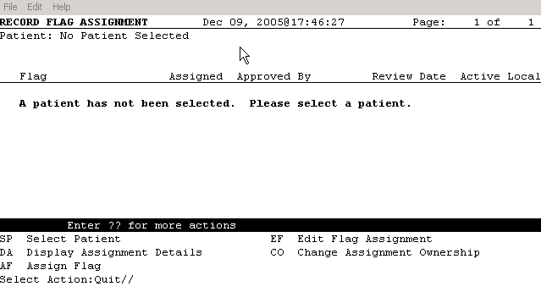

A patient has not been selected. To select at patient enter SP Select Patient

Select Action:Quit// SP Select Patient
Select PATIENT NAME: ZZ PATIENT,TEST THREE <CA> M 01-15-1968 3
Enter RETURN to continue or '^' to exit:

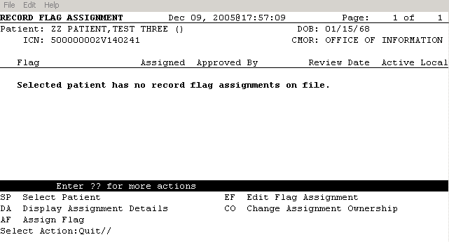

The flag can now be assigned:
Select Action:Quit// AF Assign Flag
Select a flag for this assignment: BEHAVIORAL
Searching for a National Flag
BEHAVIORAL ACTIVE BEHAVIORAL
...OK? Yes// (Yes)
Enter Owner Site: ZZ.EHR OFFICE//
Approved By: DOCTOR,TWO DT Physician

Enter Narrative Text for this record flag assignment: (Enter the narrative at this prompt)
PatiEnter Review Date: (12/9/2005 - 12/9/2007): 12/9/2007// (DEC 09, 2007)
Would you like to file this new record flag assignment? YES//
Filing the patient's new record flag assignment...
>>> Assignment was filed successfully.
Enter RETURN to continue or '^' to exit:

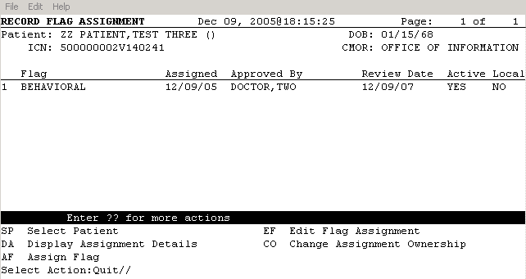

DISPLAY OF PRFs IN CPRS GUI

After selecting a patient record on the Patient Selection screen if the patient has a PRF you will
see a box for Patient Record Flags as below.

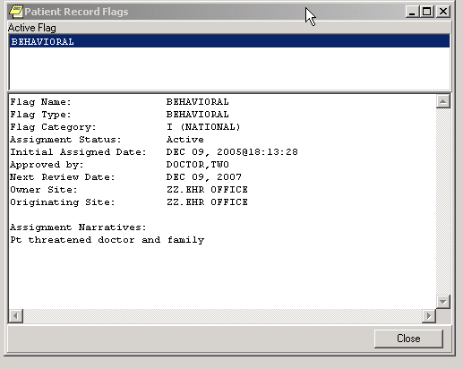

After closing the window and entering the patients’ chart on the coversheet you will see the Red “Flag” button and the patient’s flag.

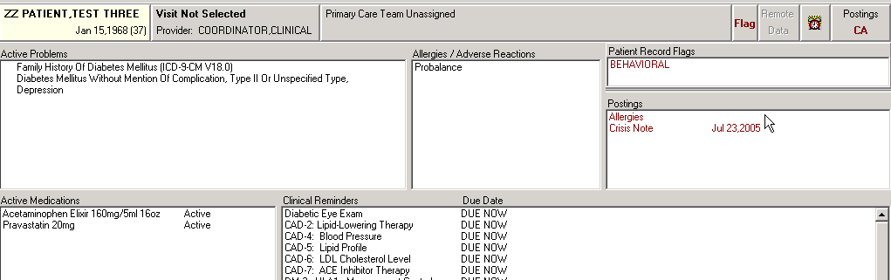

To view details of the flag you may click on the Flag type (in this example BEHAVIORAL)

