Clinical Reminders 101
Clinical Reminders are the VistA workhorse for Patient Quality Improvement, especially in Preventative Care and Chronic Disease Management. Clinical Reminders quietly access every patient that is selected in CPRS. Then based upon criteria and logic contained in the Clinical Reminder, the computer will alert the provider of screening tests and disease management due for that individual patient.

Because Clinical Reminders (CR) are so powerful, they need to be flexible. Consider a Reminder for a PAP smear (Cervical Ca) screen:
- Some high risk women need to be screened every year, while low risk women can be screened every three years.
- The guidelines vary in when to start (sexually active, 2 years after sexually active, OR 18 years, some say 21 years, etc)
- The guidelines vary as to when patients should stop being screened.
- Some women with abnormal pap results need screening every 3-6 months, but this can change based upon the type of tests (liquid cytology), and HPV types.
- Women post-hysterectomy for benign disease and no cervix, need not be screened at all.

Subsequent lessons will deal with various methods for dealing with this complexity. For now we will learn the basics of making clinical reminders:

Every clinical reminder has two main parts:
The cohort definition, which is the group that the reminder applies to. Examples may be all active patients over the age of 50; all active patients that are female, between the ages of 21-65 years; all active patients that have a diagnosis of diabetes; etc. The cohort group (definition) is the DEMOMINATOR of the entire clinical reminder expression.

The Numerator of the CR expression is the RESOLUTION Cohort (definition, or logic). The numerator always starts with the denominator (eg ALL Active patients with a diagnosis of diabetes) and then adds then particular screen or management action for that group (eg THAT have not had a Diabetic foot exam in the last year). So in this example, if a patient is selected in CPRS: First the computer will check to see if the patient has a diagnosis of Diabetes. If true, then it will check to see if the diabetic foot exam has been done in the last year. If true, the Reminder is said to be “satisfied”. If false, the reminder is said to be “due” and will appear automatically on the coversheet to remind the clinician to “satisfy” the reminder. This is done by the clinician in the notes section of CPRS using the linked “Reminder Dialog”.

In this lesson, we will make a Clinical Reminder to access whether or nor the following question was asked within the last year: Do patients like Dr. Stephan?
Remember, we decided we would ask this question to all (active) patients between the ages of 21 to 65 (inclusive). So this is the cohort.

The reminder will be “satisfied” if the patient either answered “Yes” or “No”. (Resolution cohort).

Let's start making the Clinical Reminder:

- First Create the Clinical Reminder Definition:

core Applications

PSM Pharmacy Data Management ...
PCE PCE Coordinator Menu ...
HS Health Summary Coordinator's Menu ...
VFM VOE Fileman ...
CAC CPRS Configuration (Clin Coord) ...
CRM Reminder Managers Menu ...
..
Select Core Applications Option: crm Reminder Managers Menu

CF Reminder Computed Finding Management ...
RM Reminder Definition Management ...
SM Reminder Sponsor Management ...
TXM Reminder Taxonomy Management ...
TRM Reminder Term Management ...
LM Reminder Location List Management ...
RX Reminder Exchange
RT Reminder Test
OS Other Supporting Menus ...

Select Reminder Managers Menu Option: rm RM Reminder Definition Management

RL List Reminder Definitions
RI Inquire about Reminder Definition
RE Add/Edit Reminder Definition
RC Copy Reminder Definition
RA Activate/Inactivate Reminders
RH Reminder Edit History

Select Reminder Definition Management Option: ADD/Edit Reminder Definition

Select Reminder Definition: STEPHAN VANITY CR
Are you adding 'STEPHAN VANITY CR' as
a new REMINDER DEFINITION (the 168TH)? No// Y (Yes)
REMINDER DEFINITION CLASS: L LOCAL

NAME: STEPHAN VANITY CR//

PRINT NAME: STEPHAN PATIENT SURVEY

CLASS: LOCAL//
SPONSOR: <enter>
REVIEW DATE: <enter>
USAGE: ??
The Usage field describes how the reminder definition will be
used. This field must contain C if the reminder is to be selected
in CPRS. The L value will override all other values. For
example, if L and C are defined in the usage field, the Reminder
will not show on the cover sheet in CPRS, because L is in the
Usage field.

This is free text field and can contain any combination of the
following codes:

Code Usage
C CPRS
L Reminder Patient List
P Patient
R Reminder Reports
X Reminder Extracts
* All of the above, except L and P.

USAGE: *

INACTIVE FLAG: <enter>
IGNORE ON N/A: <enter>
RESCISSION DATE: <enter>

DESCRIPTION:
1>t THIS PATIENT SURVEY FOR DOCTOR STEPHEN IS TO DETERMINE WHETHER ETHER PATIENT ATTITUDES TOW
ARD THIS PROVIDER
2><enter>
EDIT Option: <enter>

TECHNICAL DESCRIPTION:
1>COHORT LOGIC IS ALL PATIENTS BETWEEN 21 AND 65
2>RESOLUTION LOGIC IS BASED UPON SATISFIED WW ITH THE HEALTH sTEPHAN - STEPHAN YES or STEPHAN NO
3>
EDIT Option: <enter>

PRIORITY: ??
REMINDER PRIORITY is used by the CPRS GUI for sorting purposes.

Choose from:
1 HIGH
2 MEDIUM
3 LOW
PRIORITY: 3 LOW

Baseline Frequency<enter>
DO IN ADVANCE TIME FRAME: 1M
SEX SPECIFIC: <enter>

Baseline frequency age range set
Select REMINDER FREQUENCY: 1Y
Are you adding '1Y' as a new REMINDER FREQUENCY (the 1ST for this REMINDER DE
FINITION)? No// Y (Yes)
MINIMUM AGE: 21
MAXIMUM AGE: 65
AGE MATCH TEXT:
1>THIS REMINDER APPLIED BECAUSE PATIENT MEETS AGE CRITERIA
2><enter>
EDIT Option: <enter>
AGE NO MATCH TEXT:
1>THIS REMINDER DO NOT APPLY BECAUSE PATIENT IS NOT BETWEEN 21-65 AT THE TIME
OF ACCESS ASSESSMENT.
2><enter>
EDIT Option: <enter>
Select REMINDER FREQUENCY: <enter>

Reminder Definition Findings

Reminder has no findings

Select FINDING: ??
You may enter a new FINDINGS, if you wish
This field identifies the finding items included in the reminder
definition.
Enter one of the following:
DR.EntryName to select a DRUG
ED.EntryName to select a EDUCATION TOPIC
EX.EntryName to select a EXAM
HF.EntryName to select a HEALTH FACTOR
IM.EntryName to select a IMMUNIZATION
LT.EntryName to select a LABORATORY TEST
MH.EntryName to select a MH TESTS AND SURVEYS
'^' TO STOP:
RP.EntryName to select a RADIOLOGY PROCEDURE
CF.EntryName to select a REMINDER COMPUTED FINDING
TX.EntryName to select a REMINDER TAXONOMY
RT.EntryName to select a REMINDER TERM
ST.EntryName to select a SKIN TEST
DC.EntryName to select a VA DRUG CLASS
DG.EntryName to select a VA GENERIC
VM.EntryName to select a VITAL MEASUREMENT
RL.EntryName to select a REMINDER LOCATION LIST

To see the entries in any particular file type <Prefix.?>

If you simply enter a name then the system will search each of
the above files for the name you have entered. If a match is
found the system will ask you if it is the entry that you desire.

However, if you know the file the entry should be in, then you can
speed processing by using the following syntax to select an entry:
<Prefix>.<entry name>
or
<Message>.<entry name>
'^' TO STOP:
<File Name>.<entry name>

Also, you do NOT need to enter the entire file name or message
to direct the look up. Using the first few characters will suffice.

Select FINDING: HF.STEPHAN

Searching for a HEALTH FACTOR, (pointed-to by FINDING ITEM)

Searching for a HEALTH FACTOR

1 STEPHAN NO
2 STEPHAN RATINGS
3 STEPHAN YES
CHOOSE 1-3: 1 STEPHAN NO
Are you adding 'STEPHAN NO' as a new FINDINGS (the 1ST for this REMINDER DEFI
NITION)? No// Y (Yes)

Editing Finding Number: 1
FINDING ITEM: STEPHAN NO// <enter>
REMINDER FREQUENCY: <enter>
MINIMUM AGE: <enter>
MAXIMUM AGE: <enter>
RANK FREQUENCY: <enter>
USE IN RESOLUTION LOGIC: ! OR
USE IN PATIENT COHORT LOGIC: <enter>
BEGINNING DATE/TIME: <enter>
ENDING DATE/TIME: <enter>
OCCURRENCE COUNT: <enter>
WITHIN CATEGORY RANK: <enter>
INCLUDE VISIT DATA: <enter>
CONDITION: <enter>
CONDITION CASE SENSITIVE: <enter>
USE STATUS/COND IN SEARCH: <enter>
FOUND TEXT:
1><enter>
NOT FOUND TEXT:
1><enter>

Reminder Definition Findings

Choose from:
HF STEPHAN NO Finding #: 1

Select FINDING: HF.STE

Searching for a HEALTH FACTOR, (pointed-to by FINDING ITEM)
STEPHAN NO
...OK? Yes// N (No)

Searching for a HEALTH FACTOR

1 STEPHAN NO
2 STEPHAN RATINGS
3 STEPHAN YES
CHOOSE 1-3: 3 STEPHAN YES
Are you adding 'STEPHAN YES' as a new FINDINGS (the 2ND for this REMINDER DEF
INITION)? No// Y (Yes)

Editing Finding Number: 2
FINDING ITEM: STEPHAN YES// <enter>
REMINDER FREQUENCY: <enter>
MINIMUM AGE: <enter>
MAXIMUM AGE: <enter>
RANK FREQUENCY: <enter>
USE IN RESOLUTION LOGIC: ! OR
USE IN PATIENT COHORT LOGIC: <enter>
BEGINNING DATE/TIME: <enter>
ENDING DATE/TIME: <enter>
OCCURRENCE COUNT: <enter>
WITHIN CATEGORY RANK: <enter>
INCLUDE VISIT DATA: <enter>
CONDITION: <enter>
CONDITION CASE SENSITIVE: <enter>
USE STATUS/COND IN SEARCH: <enter>
FOUND TEXT:
1> <enter>
NOT FOUND TEXT:
1> <enter>

Function Findings
Select FUNCTION FINDING: ^

Patient Cohort and Resolution Logic
CUSTOMIZED PATIENT COHORT LOGIC (OPTIONAL): ^

Select one of the following:

A All reminder details
G General
B Baseline Frequency
F Findings
FF Function Findings
L Logic
C Custom date due
D Reminder Dialog
W Web Addresses

Select section to edit: D Reminder Dialog

Reminder Dialog
LINKED REMINDER DIALOG: STEPHANS POPULARITY CONTEST reminder dialog
LOCAL
...OK? Yes// Y (Yes)

Select one of the following:

A All reminder details
G General
B Baseline Frequency
F Findings
FF Function Findings
L Logic
C Custom date due
D Reminder Dialog
W Web Addresses

We should make sure the CR is activated:

Select Core Applications Option: CRM Reminder Managers Menu

CF Reminder Computed Finding Management ...
RM Reminder Definition Management ...
SM Reminder Sponsor Management ...
TXM Reminder Taxonomy Management ...
TRM Reminder Term Management ...
LM Reminder Location List Management ...
RX Reminder Exchange
RT Reminder Test
OS Other Supporting Menus ...
INFO Reminder Information Only Menu ...
DM Reminder Dialog Management ...
CP CPRS Reminder Configuration ...
RP Reminder Reports ...
MST Reminders MST Synchronization Management ...
PL Reminder Patient List Menu ...
PAR Reminder Parameters ...
XM Reminder Extract Menu ...
GEC GEC Referral Report

You've got PRIORITY mail!

Select Reminder Managers Menu Option: RM Reminder Definition Management

RL List Reminder Definitions
RI Inquire about Reminder Definition
RE Add/Edit Reminder Definition
RC Copy Reminder Definition
RA Activate/Inactivate Reminders
RH Reminder Edit History

You've got PRIORITY mail!

Select Reminder Definition Management Option: RA Activate/Inactivate Reminders

Select REMINDER DEFINITION NAME: STEPHAN VANITY CR LOCAL
INACTIVE FLAG:

NO “1' IS DISPLAYED ON INACTIVE FLAG, SO THE REMINDER IS ACTIVE.

NOW IF WE WANT, WE CAN TURN IT ON AT THE DIVISION, LOCATION OR SYSTEM LEVEL SO EVERYONE HAS TO DO IT, OR HAS THE OPTION TO DO IT:

Select Reminder Managers Menu Option: CP CPRS Reminder Configuration

CA Add/Edit Reminder Categories
CL CPRS Lookup Categories
CS CPRS Cover Sheet Reminder List
MH Mental Health Dialogs Active
PN Progress Note Headers
RA Reminder GUI Resolution Active
TIU TIU Template Reminder Dialog Parameter
DL Default Outside Location
PT Position Reminder Text at Cursor
NP New Reminder Parameters
GEC GEC Status Check Active
WH WH Print Now Active

Select CPRS Reminder Configuration Option: CS CPRS Cover Sheet Reminder List

Clinical Reminders for Search may be set for the following:

1 User USR [choose from NEW PERSON]
2 Location LOC [choose from HOSPITAL LOCATION]
3 Service SRV [choose from SERVICE/SECTION]
4 Division DIV [VOE OFFICE INSTITUTION]
5 System SYS [BETA.VISTA-OFFICE.ORG]
6 Package PKG [ORDER ENTRY/RESULTS REPORTING]

Enter selection: 2 Location HOSPITAL LOCATION
Select HOSPITAL LOCATION NAME: JON DOE CLINIC

---- Setting Clinical Reminders for Search for Location: JON DOE CLINIC ----
Select Display Sequence: 5
Are you adding 5 as a new Display Sequence? Yes// YES

Display Sequence: 5// 5
Clinical Reminder: STEPHAN VANITY CR LOCAL
Select Display Sequence:

CA Add/Edit Reminder Categories
CL CPRS Lookup Categories
CS CPRS Cover Sheet Reminder List
MH Mental Health Dialogs Active
PN Progress Note Headers
RA Reminder GUI Resolution Active
TIU TIU Template Reminder Dialog Parameter
DL Default Outside Location
PT Position Reminder Text at Cursor
NP New Reminder Parameters
GEC GEC Status Check Active
WH WH Print Now Active

Select CPRS Reminder Configuration Option:

WE ARE NOW DONE IN Putty!

Now we can go into CPRS and Check our work:

This first screen is how to individually add the Clinical Reminder to your CPRS.
Go to Tools, then Options, then Clinical Reminders:
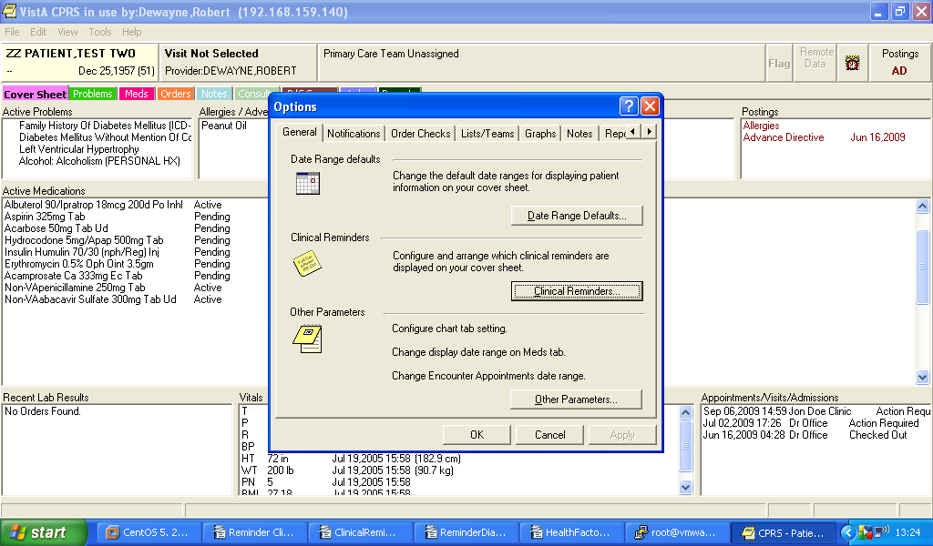

Locate the reminder under the Available Reminders and Categories, Click and move it over using the arrow (see below). Then click “Add”.
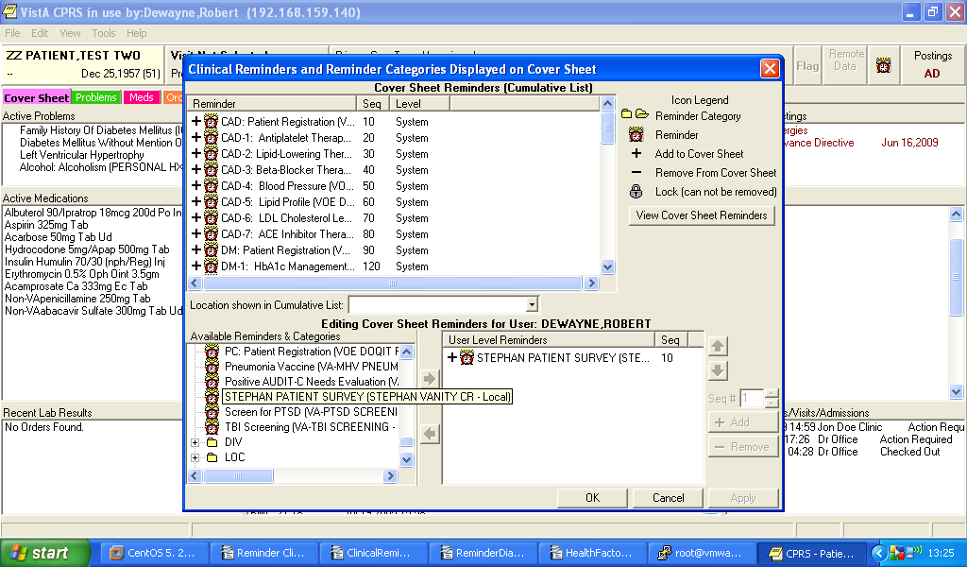

If you return to the coversheet and refresh the patient (under “File Menu”), you will see the new reminder: You can also right click it and choose Clinical maintenance to see why the Reminder applies to this patient.
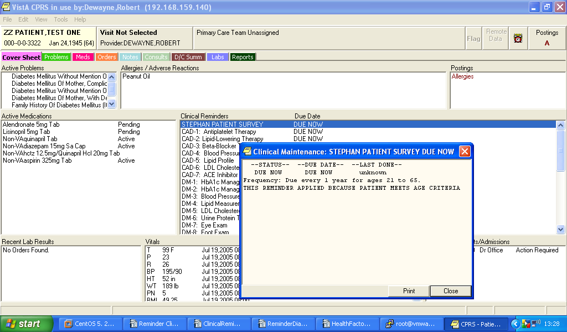

Go to the notes tab and open the reminder draw to satisfy the reminder using the attached dialog.
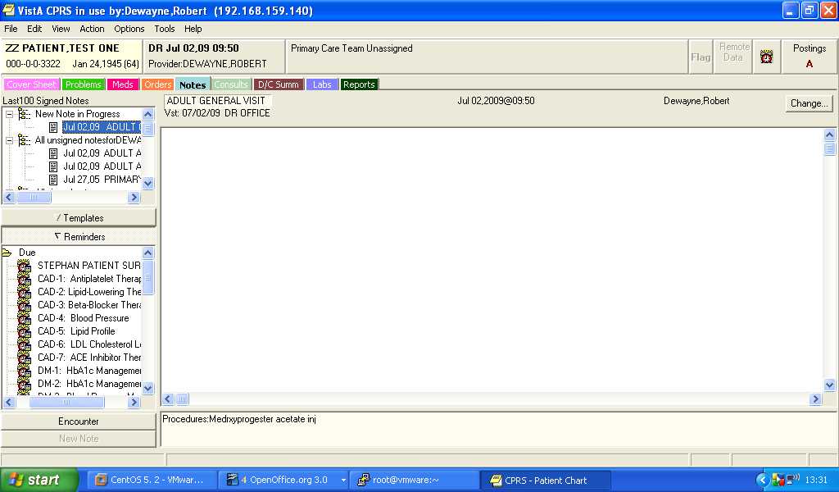

Use the Dialog to complete the Survey.

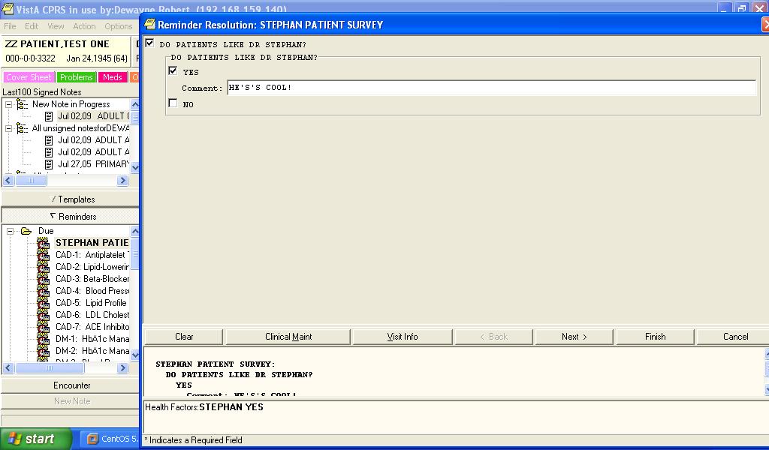
After refreshing the patient, the reminder disappears from the coversheet.

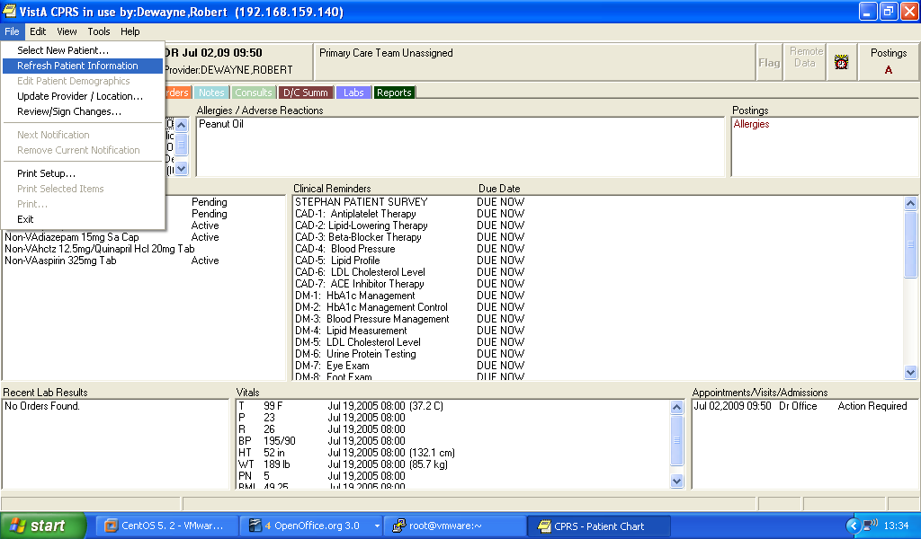

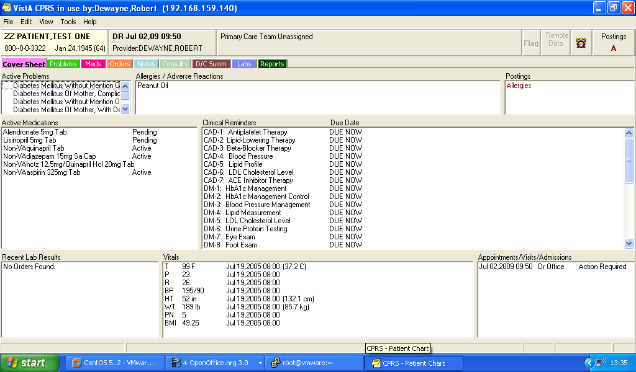

Health Factor default behavior:

The issue seems to be an understanding of how health factors work in reminder evaluation. The default behavior is: only the most recent health factor in a category can be true. An example of where this is useful is tracking smoking history. When a patient is given a health factor marking them as a smoker then a smoking cessation reminder is applicable. If they quit, and are given a non-smoker health factor the cessation reminder no longer applies. They start smoking again and are given are new instance of the smoker health factor making the cessation reminder again applicable.The series of health factors provides a history of the patient's smoking status. When you do not want this default behavior in reminder evaluation that is when you set WITHIN CATEGORY RANK to 0.

